PARTER LOGO 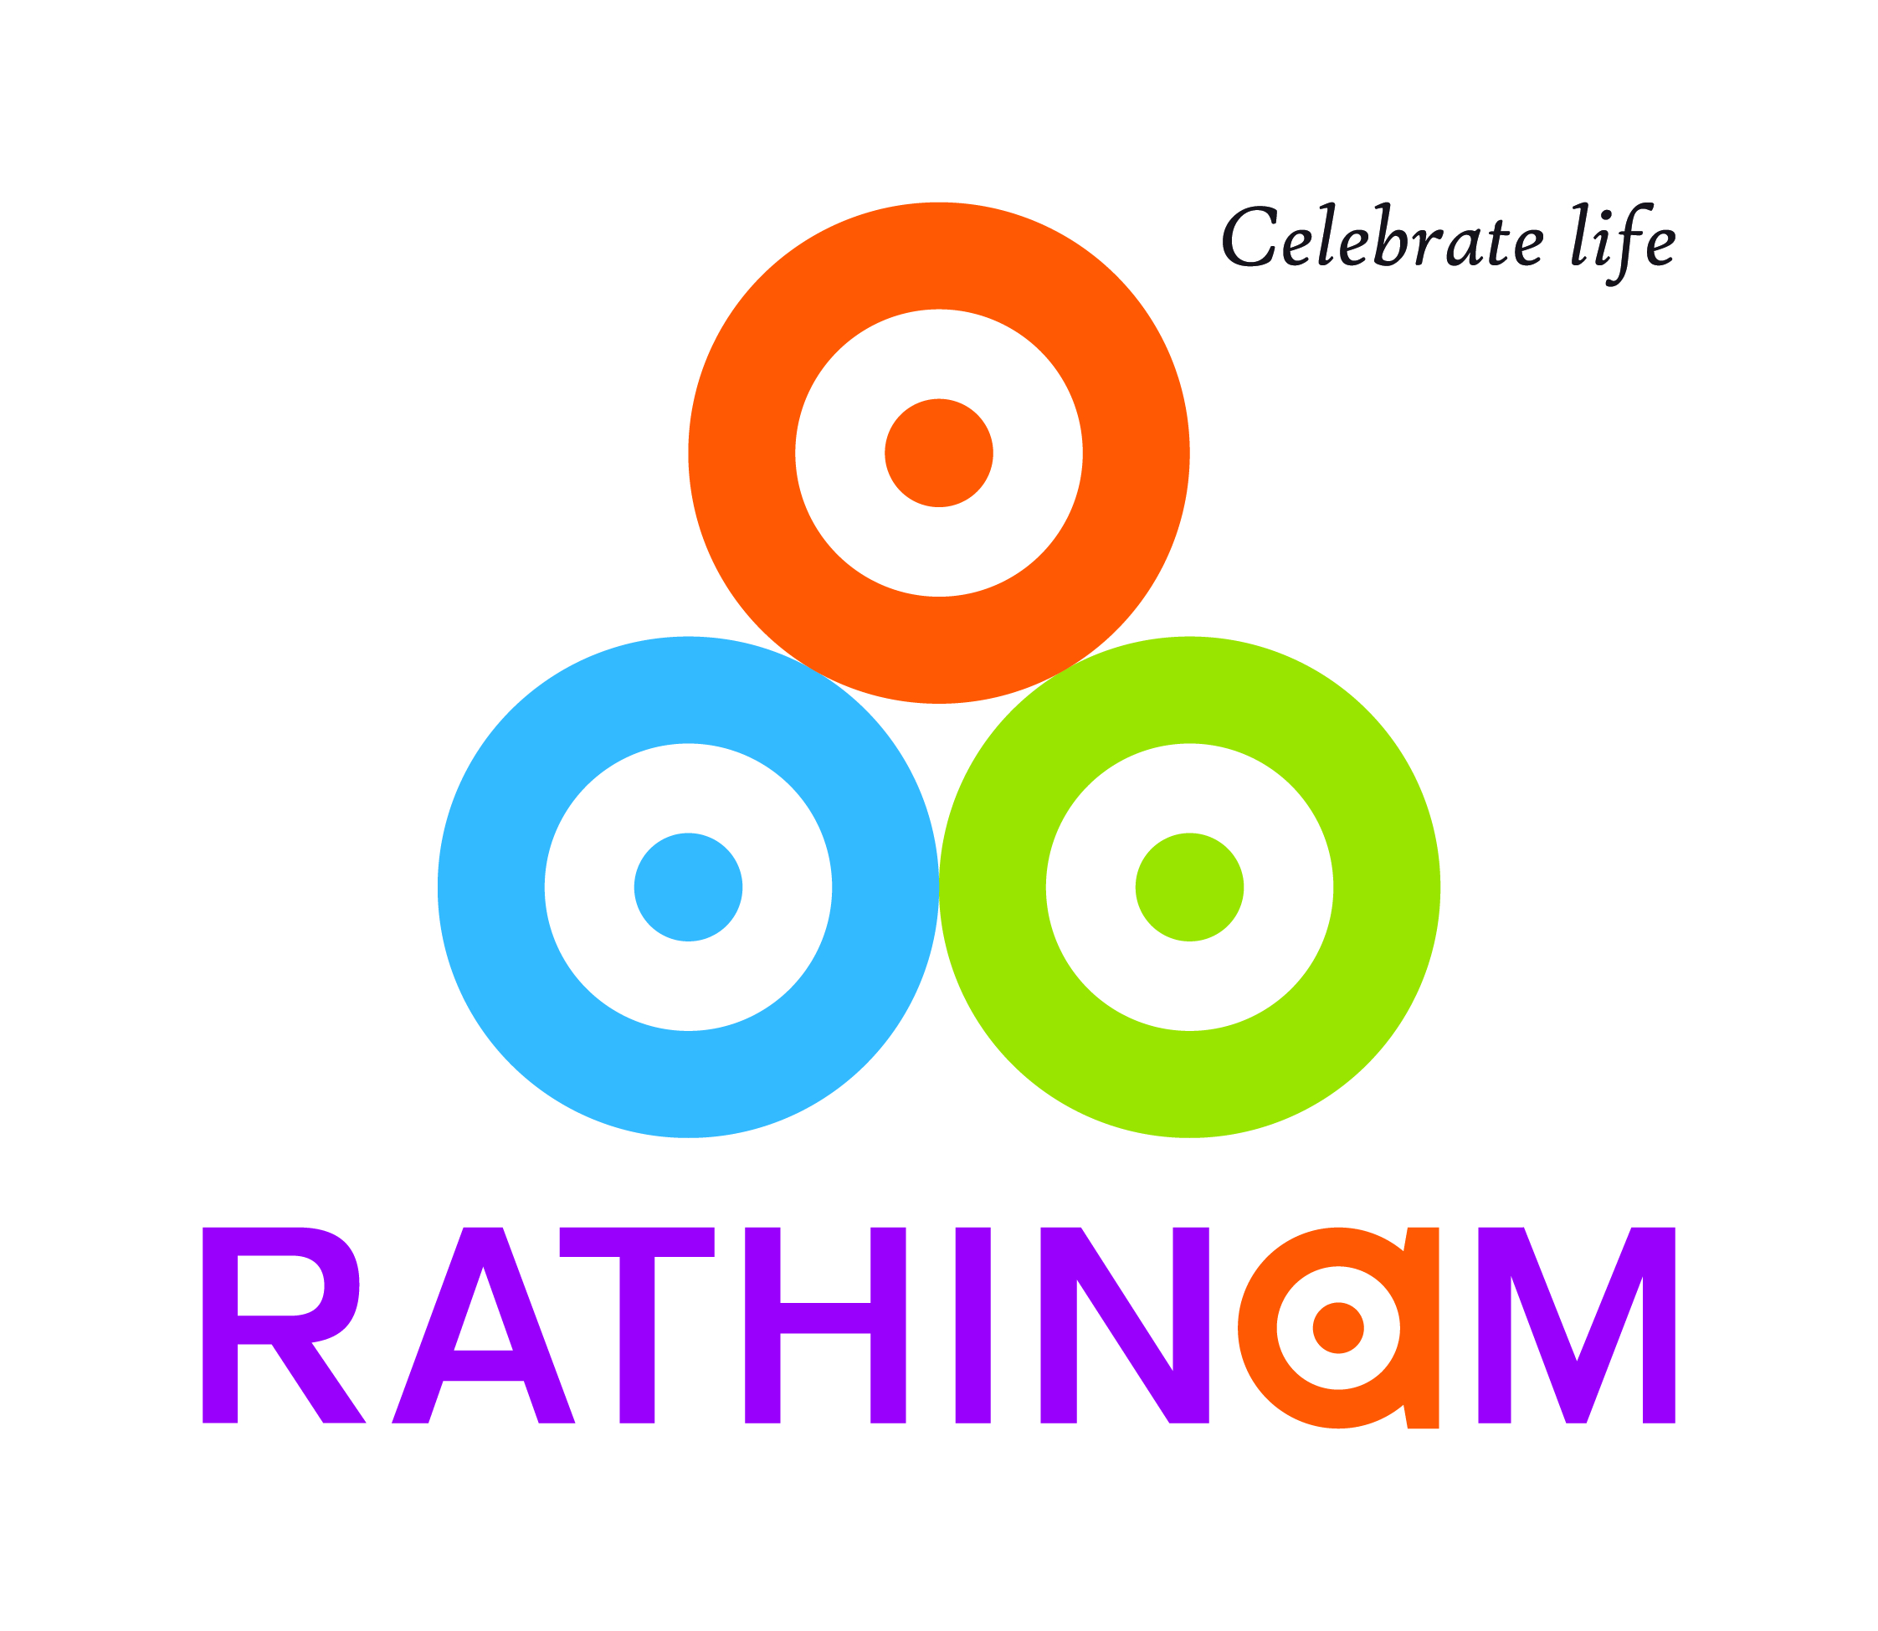

MEMORANDUM OF UNDERSTANDING

BETWEEN

THE UNIVERSITY OF [ name ]

AND

THE RATHINAM GROUP OF INSTITUTIONS
(RIT, RIM, RCAS)

This Memorandum of Understanding (hereafter MOU) between the University of [ name ] and the Rathinam Group of Institutions constitutes a framework for cooperation between the two parties.

Article 1

The MOU’s objective is to facilitate further cooperation in research and education. This MOU is a statement of intent to foster genuine and mutually beneficial collaboration.

Article 2

This MOU shall remain in force for an initial period of five (5) years from the date of the last signature. Thereafter it shall be automatically renewed for successive five-year periods, unless either University terminates this Agreement by giving six months written notice to the other party. Any amendments to the MOU are subject to approval in writing by both parties.

In case of disagreements between the two parties, this MOU can be cancelled by both parties by giving six months written notice prior to the date of cancellation.

Article 3

The two parties should seek to promote:
- Mobility of graduate and/or undergraduate students
- Mobility of faculty and/or staff
- Joint research activities and publications
- Participation in seminars and academic meetings
- Exchange of academic materials and academic publications;
- Special short-term academic programs

Article 4

The parties may sign an Intellectual Property Rights (IPR) document in order to secure rights when it comes to research results and publications.

Article 5

Participating staff and students involved in any activities under this MOU must adhere to the law of the host countries and rules and regulations of the host institutions.

Article 6

Both parties welcome the establishment of this document and agree to the provisions given above.

There will be XXX copies of this MOU equally valid, XXX for each party.

University [ name ] | Rathinam Group of Institutions,
…………………………………………..  President or Vice-Chancellor  ……………………………………...  In block letters  Date (dd.mm.year)……………………… | …………………………………………..  Chairman  …………….…………………………...  In block letters  Date (dd.mm.year)………………………
Seal | Seal

University XXXX | Rathinam Group of Institutions
www.nvnvnnv | www.rathinamcollege.com
Registered address | Eachanari, Coimbatore – 641021,
XXXXXXXXXXXX | Tamil Nadu, India.

